**Strategies for E-cadherin Recycling: A Computational Model**

**A PROJECT REPORT**

*Submitted as part of BBD451 BTech Major Project (BB1)*

*Submitted by:*

**Vaibhav Agarwal 2020BB10061**

*Guided by:*

**Professor Amit Das**



**DEPARTMENT OF BIOCHEMICAL ENGINEERING AND BIOTECHNOLOGY**

**INDIAN INSTITUTE OF TECHNOLOGY DELHI**

**November 2023**

## DECLARATION

I certify that

* 1. the work contained in this report is original and has been done by me under the guidance of my supervisor(s).
  2. I have followed the guidelines provided by the Department in preparing the report.
  3. I have conformed to the norms and guidelines given in the Honor Code of Conduct of the Institute.
  4. whenever I have used materials (data, theoretical analysis, figures, and text) from other sources, I have given due credit to them by citing them in the text of the report and giving their details in the references. Further, I have taken permission from the copyright owners of the sources, whenever necessary.

*Signed by:*

## Name of the Student

## CERTIFICATE

It is certified that the work contained in this report titled “**Strategies for E-cadherin Recycling: A Computational Model**” is the original work done by **Vaibhav Agarwal** and has been carried out under my supervision.

*Signed by:*

## Name of the Faculty Mentor

## Date:

## ABSTRACT

Adhesion receptors, such as E-Cadherin, are crucial proteins found on the cell surface that facilitate cell adhesion by mediating physical attractions between the cell and its surrounding environment, specifically the extracellular matrix (ECM). E-Cadherin plays a pivotal role in various biological functions, including cell attachment, mobility, and signal communication. A notable feature of E-Cadherin is its ability to form mechanical links between neighbouring cells in epithelial tissues, which underpin many multicellular processes. These molecules tend to cluster, providing stability to the mechanical links between cells. E-Cadherin molecules are not omnipresent at the cell surface rather they undergo constant cycles of endo- and exocytosis. This project focusses on the mechanisms controlling E-Cadherin's recycling process. Using the Drosophila follicular epithelium as a model, this study uses computational modelling to delve into the physical processes behind E-Cadherin recycling following an endocytosis event. We invoke Langevin dynamics simulations of E-Cadherin molecules at the cell membrane as a two-dimensional platform to recapitulate their clustering dynamics. Furthermore, we develop algorithms representing the different exocytosis channels of E-Cadherin to predict a possible physical framework for E-Cadherin recycling in general.

**TABLE OF CONTENTS**

|  |  |
| --- | --- |
|  | Page |
| Declaration | 2 |
| Certificate | 3 |
| Abstract | 4 |
| Table of Contents | 5 |
| List of Abbreviations | 6 |
| **Chapter 1 : Introduction** | 7 |
| **Chapter 2 : Motivation** | 8 |
| **Chapter 3 : Literature Survey** | 9 |
| **Chapter 4 : Material and Methods** | 11 |
| **Chapter 5 : Result and Discussion** | 17 |
| **Chapter 6 : Summary and Conclusion** | 20 |
| **References** | 22 |
| Appendex A: Python Program | 24 |

**LIST OF ABBREVIATIONS**

|  |  |
| --- | --- |
| **Abbreviation** | **Description** |
| ECM | Extracellular Matrix |
| PM | Plasma Membrane |
| ZA | Zonula Adherens |
| Rab11, RabX1, Rab5 | Member of Rab family of GTPases |
| DE-cad | Drosophilla E-cadherin |
|  |  |
|  |  |

**Chapter 1**

**INTRODUCTION**

Cells utilize adhesion molecules to interact with their surroundings [1-3]. These structural proteins emerge from non-covalent bonds between adhesion molecules on one cell surface and receptors on adjacent cells or mediator molecules within the Extracellular Matrix (ECM). Cell adhesions are pivotal for maintaining tissue cohesion and facilitating cell communication. Through these adhesions, cells can transmit forces, enabling interaction and sensing.

E-cadherin, a transmembrane protein, is paramount in orchestrating cell attachment in epithelial cells. The accumulation of E-cadherin at intracellular junctions is vital for preserving tissue integrity and modulating epithelial tissue activity. Cell-cell adhesion is fortified when E-cadherin receptors on neighbouring cells interact and cluster at the cellular membrane. The integrity of tissues and the regulation of epithelial tissue activities hinge on the aggregation of E-cadherin at these intracellular boundaries and the maturation of these cell-cell adhesions [6].

E-cadherin facilitates cell-cell adhesion by establishing homophilic contacts with E-cadherin molecules on adjacent cells. The intracellular domain of E-cadherin interacts with several cytoplasmic proteins, including beta-catenin, alpha-catenin, and p120 catenin. These interactions are essential for linking the E-cadherin adhesion complex to the cell's actin cytoskeleton. The formation of E-cadherin clusters at cellular interfaces is a pivotal step in the evolution of cell-cell adhesion. The lateral association of E-cadherin molecules, facilitated by calcium-dependent interactions and connections between the cytoplasmic domains of E-cadherin and catenin, leads to the clustering of E-cadherin [1].

Associations between E-cadherin and F-actin are mediated by beta-catenin, alpha-catenin, and other F-actin-binding proteins like Vinculin and EPLIN. As epithelia develop, significant restructuring of cell junctions occurs. This necessitates the regulation of cell-cell adhesion, such as by modulating cadherin levels or renewing them through endocytic recycling. A recycling mechanism redistributes E-cadherin from the lateral PM to the apicolateral PM, leading to its accumulation at the ZA. Recycling involves molecular interactions between Rab11, the exocyst complex, and beta-catenin. The study identifies RabX1 as a critical new component for DE-cadherin recycling, placing its function between the early and the recycling endosome. In RabX1 mutants, endocytosed DE-cadherin protein is not properly recycled but accumulates together with Rab5 and Rab11 in a large compartment. This targeted recycling is essential for the maintenance of the ZA and cell shape.

**Chapter 2**

**MOTIVATION**

The cellular landscape is a complex web of interactions, processes, and dynamics. Within this intricate framework, the recycling of molecules, particularly e-cadherin, stands out as a pivotal process. E-cadherin, a cornerstone of cell-cell adhesion, plays a significant role in maintaining tissue integrity and orchestrating various cellular activities. Its recycling, specifically through endocytosis, is a managed interaction that influences its organization on the cell surface of numerous metazoan organisms.

Given the importance of e-cadherin and its recycling, understanding the nuances of this process is crucial. Dysregulation of E-cadherin endocytosis has been linked to various diseases, including cancer and developmental disorders. For instance, rapid e-cad acquisition by endocytosis and a significant reduction in E-cadherin concentrations are associated with the collapse of the columnar epithelial structure during epithelial-mesenchymal transition (EMT), a critical phase in cancer development [1]. Variations in the appearance of adhesion molecules have also been identified as a cause of the cell-sorting process in tissue culture.

However, despite its significance, several aspects of e-cadherin recycling remain enigmatic. The nature of specific interactions leading to e-cadherin clustering, the dynamics of its endocytosis, and its movement on the cell surface are areas that require deeper exploration. Traditional experimental methods, while invaluable, may not capture the full spectrum of molecular dynamics and interactions at play [1].

This is where computational modelling steps in. Computational modelling offers a powerful tool to simulate, analyse, and predict the behaviour of molecules in various scenarios. By leveraging computational tools, we can delve into the microscopic world of e-cadherin recycling, exploring the nature of interactions between E-cadherins and understanding the coupling between the dynamics of endocytosis and the movement of E-cadherin on the cell surface. Such models can provide insights that are challenging to obtain through experimental means alone.

Furthermore, the research paper highlighted the role of Rab11 in controlling the transport of newly synthesized E-cadherin from the Golgi to the plasma membrane, emphasizing the significance of recycling pathways in maintaining E-cadherin's presence at the ZA [13]. By integrating these insights into computational models, we can gain a holistic understanding of the recycling process, its regulatory mechanisms, and its implications in health and disease.

**Chapter 3**

**LITERATURE SURVEY**

Endocytosis, a key cellular process, plays a pivotal role in modulating the amount of E-cadherin on cellular interfaces. This recycling mechanism not only regulates the distribution of E-cadherin but also selectively targets and reduces the formation of large E-cadherin clusters. The underlying hypothesis suggests that larger clusters might be more susceptible to endocytosis due to their propensity to facilitate the assembly of endocytic machinery. Such macroscopic clusters, if unchecked, could potentially disrupt the actomyosin system, leading to a cessation of tissue movements. By regulating the size and distribution of these clusters through recycling, endocytosis ensures the smooth functioning of cellular processes. [13]

**Figure 3.1 : Model displaying the mechanisms to control DE-cad localization**

While E-cadherin can aggregate independently of actin, experimental data underscores the importance of E-cadherin's associations with actin for maintaining cluster stability in live epithelia. Recent computational models have proposed that E-cadherin might spontaneously aggregate under the influence of lateral forces [7]. Actin-based control plays a crucial role in preventing the disintegration of cadherin complexes. Despite evidence suggesting that E-cadherin mediates force transmission between the cytoskeleton and the cellular environment, the capacity of E-cadherin clustering to regulate this force transfer remains an area of active research [1]. The recycling of E-cadherin, especially through endocytosis, is thought to play a role in stabilizing these clusters and maintaining cellular adhesion.[7]

E-cadherin's role in cellular motility is multifaceted. While it restricts cell movement on matrices, its influence on cell movement through cell-rich tissues remains ambiguous. In-depth studies using in vivo mechanical stress sensors and other advanced techniques have revealed that E-cadherin-mediated adhesion between border cells and nurse cells stabilizes forward-directed protrusion, ensuring consistent mobility. This adhesion mechanism also facilitates cellular communication, with leading cells providing directional cues to follower cells. [2]

RAB5A, an essential endocytic protein, has been observed to stimulate the formation of distinct actin-based protrusions. These protrusions generate traction forces that are transmitted over extended distances through junctional contacts. This intricate interplay between mechanical coupling and polarity establishes a feedback loop, enabling cells to receive directional cues from neighboring cells. Such interactions enhance the dynamism of multicellular organisms, optimizing junctional E-cadherin dynamics to accommodate changes in cellular proximity, volume, density, and stress. The recycling of E-cadherin, especially its redistribution from lateral to apicolateral regions, plays a crucial role in this dynamic process. [3]

Metastasis is a leading cause of cancer-related deaths. A notable observation is the inverse relationship between in vitro movement and E-cadherin concentrations. Despite the majority of breast cancers being invasive ductal carcinomas that express E-cadherin, its depletion has been linked to increased invasion. However, this also results in reduced tumor growth, survival, and metastatic spread. Strategies targeting E-cadherin-mediated survival pathways could offer potential therapeutic avenues for metastatic breast cancer.[5]

**Chapter 4**

**MATERIAL AND METHODS**

When two cells come into contact, the E-cadherin molecules on their surfaces become crucial. These molecules from each cell engage with each other, leading to the cells sticking together. The bond between the cells strengthens when E-cad molecules group together on one cell and connect with similar clusters on an adjacent cell.

**Figure 4.1 : E-cadherin clustering driven by F-actin**

According to recent reports (Truong-Quang et al), F-actin plays a pivotal role in giving rise to the lateral movements of E-cadherin molecules at the cell surface. The E-cadherin molecules which come together then engage in cis-interactions which lead to cluster formation. These clusters are believed to regulate the maturation of cell-cell junctions where they engage in trans-interactions with clusters of E-cadherin from another nearby cell surface (Charras et al, current ref 10). However, the principles that dictate these molecular groupings and interactions are yet to be defined. [1]

To delve deeper into these interactions, we base our analysis on certain presumptions. We use the Langevin equation to guide the movement of these protein molecules:

𝑑2X / d𝑡2 = - Γ 𝑑𝑋⁄𝑑𝑡 + 𝐹i𝑛𝑡 + 𝐹𝑟𝑎𝑛𝑑𝑜𝑚 Eq.(4.1)

In this equation, the left side signifies a particle's acceleration in the x-direction, which also represents the inertial force. Γ stands for the friction coefficient, 𝑑𝑋⁄𝑑𝑡 indicates the velocity of the particle, 𝐹 denotes the force of interaction between particles, and 𝐹 random represents the force arising from the unpredictable motion of the surrounding fluid or environment [8].

We employ Computational Langevin dynamics simulations to capture the unpredictable behaviour of intricate systems like biological entities, materials, and molecular structures. This method can account for the impact of temperature variations and unforeseen forces, which are pivotal for a precise prediction of the actions of intricate systems.

The protein encounters an active random force. This force emulates the influence of F-actin found in the cell cortex, which momentarily links with the proteins, causing their movement [7]. Further resolution of this equation yields:

Γ 𝑑𝑋⁄𝑑𝑡 = 𝐹𝑟𝑎𝑛𝑑𝑜𝑚 = 𝑣 𝑛 Eq.(4.2)

𝑣 is the characteristic velocity of the protein molecules arising from F-actin, and 𝑛 is a unit vector that points in a random direction at any instant. dX is the displacement with time t. [8]

To correctly capture the bulk movement of particles, we use the Periodic Boundary Condition. In a periodic simulation setup, particle positions are replicated periodically throughout space, forming an endless grid of identical cells. The characteristics of PBC allow us to simulate a segment of the cellular interface that's significantly larger than individual protein sizes. For implementing PBC, it's essential to adhere to the minimum image convention (MIC) when determining molecular interactions. According to MIC, when molecules move past the cell's boundary, they interact with the nearest replicated image of themselves.

Instead of using the positions of all particles across all cells – a method that would lead to numerous unnecessary calculations – the conventional method focuses on interactions. The minimum image convention streamlines this by only considering the closest periodic image relative to each particle. By eliminating the farthest periodic image from the target cell, each particle's position is effectively confined within the simulation cell. This approach not only cuts down on computational demands but also ensures precise distance measurements between particles.

To integrate this convention into the programming, we utilize the np.round function from Python's NumPy library. This function allows us to round an array or a scalar value to a designated number of decimal points. Thus,

### 𝑥ij = 𝑥ij – np.round (𝑥ij/ L) L

Beyond the MIC, we also define an interaction range for the protein molecules. We postulate that proteins only interact when they come within a distance of 𝑟𝑐𝑢𝑡 from each other. This 𝑟𝑐𝑢𝑡 denotes the threshold distance between the centers of two protein molecules, beyond which they can establish a harmonic bond in our simulations. We designate 𝑟𝑐𝑢𝑡 as 2x%, characterizing the protein-protein interaction as a short-range attractive potential. In essence, proteins only engage when in close proximity; for distances exceeding 𝑟𝑐𝑢𝑡, the interaction energy becomes null.

We've now established a model for the active motion of E-cadherin molecules on a membrane segment. In this model, when two proteins come near each other, they have the potential to create a bond.

We have already modelled the E-cad recycling via a Black-Box method, in which we directly added the recycled particles back without differentiating between their origins in the cell mechanism. Now in accordance to our future plan we would design a computational model that would incorporate all the different recycling mechanisms discussed in the wild type, RabX1 mutant and Rab11 mutant.

For the sake of expediency and in alignment with the findings of our literature review, it is reasonable to postulate that the protein recycling mechanisms of Rab4, RabX1, and Rab11 are distinct.

Our observations indicate that the Rab4 protein rapidly reinstates E-cadherin molecules to the cell surface immediately following endocytosis. In contrast, Rab11 and RabX1 reintegrate these molecules at a more gradual pace. This is evident in Figure 3.1, where the Rab4 protein is depicted in grey, swiftly re-adding E-cadherin molecules post-endocytosis. Conversely, RabX1 and Rab11 facilitate this process through Apicolateral and Lateral Exocytosis, respectively, which are intrinsically more time-consuming pathways. Based on these observations, we propose a hypothesis regarding the temporal disparity in the reintegration of these recycled molecules.

Furthermore, in our comparative analysis of the three cell types, namely the Wild type, Mutant RabX1, and Mutant Rab11, distinct variations in recycling mechanisms are observed. In the Wild type, all three recycling pathways are operational. In the Mutant RabX1, both Apicolateral and Lateral Exocytosis are active, albeit with reduced efficiency. Conversely, in the Mutant Rab11, Apicolateral Exocytosis is entirely inhibited, while Lateral Exocytosis functions normally.

In each of these scenarios, we hypothesize that the efficiency of the Rab4 protein is dependent on the quantity of E-cadherin molecules present on the cell surface at any given time. This relationship is modelled by a Hill function, a common representation in cellular processes where enzyme activity is regulated. According to this model, the efficiency of Rab4 is inversely proportional to the abundance of surface E-cadherin molecules: higher efficiency is observed with fewer molecules, and efficiency diminishes as the number of surface molecules increases.

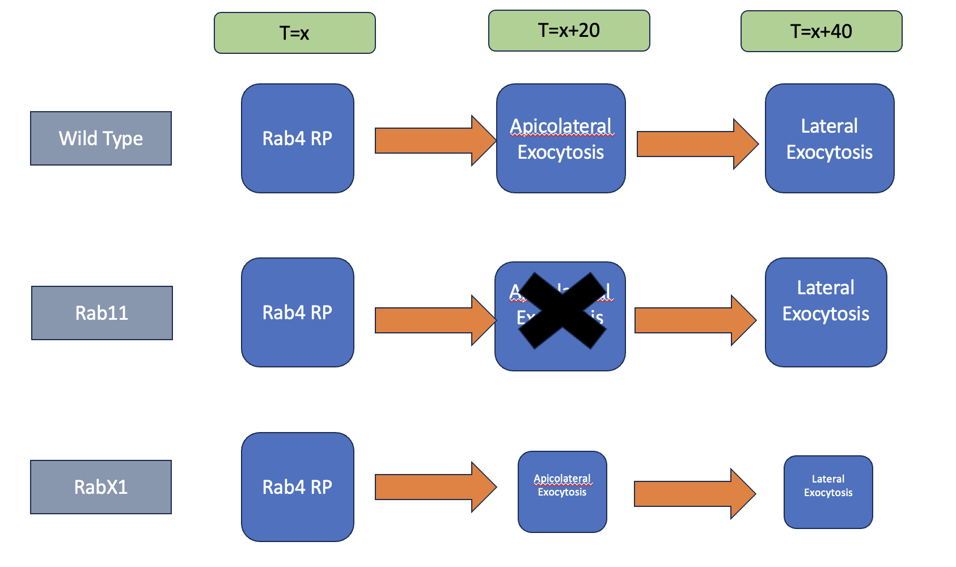

**Fig4.1**: Depicting Time and Rate after which Recyled Particles are added back[7]

In order to integrate these modifications into the computational model, we have introduced a series of variables and functions designed to distinctly delineate each mutant type. These include 'rab4_efficiency', 'tubular_efficiency', 'recycleFreqTubular', 'recycleFreqRab4', along with corresponding variables for quantifying the recycled particles for each process: 'recycled_particles_rab4', 'recycled_particles_rabx1', and 'recycled_particles_rab11'. The computation of these particle numbers is executed through the functions 'Rab4Recycle', 'Rab11Recycle', and 'RabX1Recycle'. Each function considers two parameters: the proportion of endocytosed particles allocated to a specific recycling process, and the current efficiency of that process.

**Fig 4.2**: Depicting Rab4 efficiency as a Hill Function for accurate measurements

This approach enables the creation of a more dynamic and integrated model, one that is responsive to both the external conditions on the cell surface and the internal environment within the cell, in alignment with cellular constraints and dynamics.[7]

In our model, specific values have been assigned to each variable, reflecting our previously established hypotheses. For instance, the temporal value assigned to particles reintegrated via Apicolateral Exocytosis is based on a Poisson distribution with a mean centered around 20, while for Lateral Exocytosis, this mean is around 40. Furthermore, adjustments are made to the efficiency of the Rab4 protein contingent upon the cell type under examination. In the Rab11 mutant, an enhanced efficiency of Rab4 is observed, whereas in the wild type, this efficiency is at its lowest. In the RabX1 mutant, Rab4's efficiency lies between these two extremes, as previously hypothesized and discussed.

Additionally, we postulate that the efficiency of the Rab11 protein remains constant in both the wild type and the Mutant RabX1, given that these are the only contexts in which it is active. However, in the Mutant RabX1, we hypothesize that the Rab11 operates at a significantly reduced efficiency, potentially nearly one-tenth of that observed in the wild type.[4]

This finally gives us :

endocytosis rate of 𝑘𝑒𝑛𝑑𝑜 = < 𝑛𝑑>/(𝑁𝑡Δ𝑡)

and excocytosis rate of 𝑘𝑒𝑥𝑜=<𝑛𝑎>/(𝑁𝑡Δ𝑡).

In the simulation, we supply the following sets of parameters to the random.gauss function:

𝜇𝑒𝑛𝑑𝑜 = < 𝑛𝑑 > and 𝜎𝑒𝑛𝑑𝑜 = -< 𝑛𝑑, > −< 𝑛𝑑 >, and

𝜇𝑒xo = < 𝑛a > and 𝜎𝑒𝑛𝑑𝑜 = -< 𝑛a, > −< 𝑛a >,

We keep 𝜇𝑒𝑛𝑑𝑜 ≈ 𝜇𝑒𝑥𝑜 to ensure the number of molecules present in the system at any given time remains nearly unchanged. We use same values for 𝜎𝑒𝑛𝑑𝑜 and 𝜎𝑒𝑥𝑜. The advantage of using a Gaussian distribution for describing such random processes is that it is one of the fundamental probability distributions commonly used in scientific and engineering applications, and are often a better model for natural processes than uniformly distributed random numbers.

**Chapter 5**

**RESULTS AND DISCUSSION**

Given the insights gleaned from Ms. Bagmare’s research on protein interactions and their dynamics on the cell surface, coupled with the incorporation of recycled molecules through a black-box methodology, our analysis reveals no significant differences in cell surface behavior across time traces. Consequently, we have concluded that these observations are qualitatively analogous to those noted in the Wild type. [4]

Our attention will now shift to an in-depth examination of the different cell types, specifically the Wild type, Mutant RabX1, and Mutant Rab11, with a focus on deriving both quantitative and qualitative insights from these models.

To ensure robust and quantitatively reliable results, each of the three models has been subjected to extensive simulation, running for a substantial duration of 100,000 iterations within the computational framework.

We expect results in accordance to what we discussed in Chapter 4. Lets take a lot at the plots and graphics:

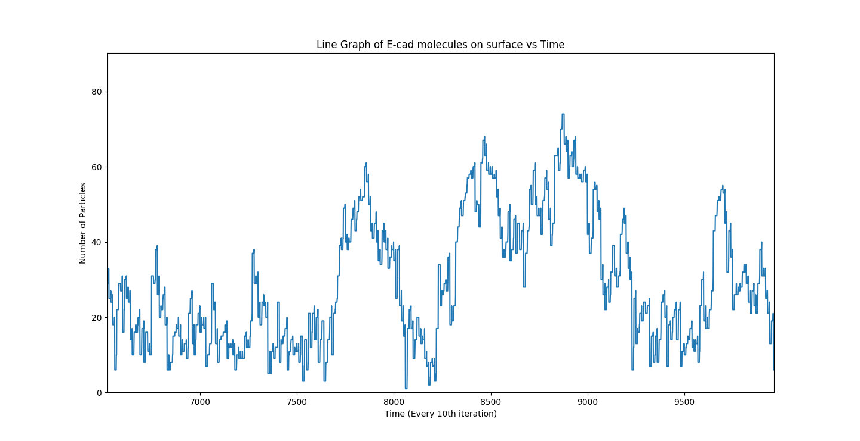

**Fig5.1:** Depicting E cad molecules on cell surface of Mutant Rab11

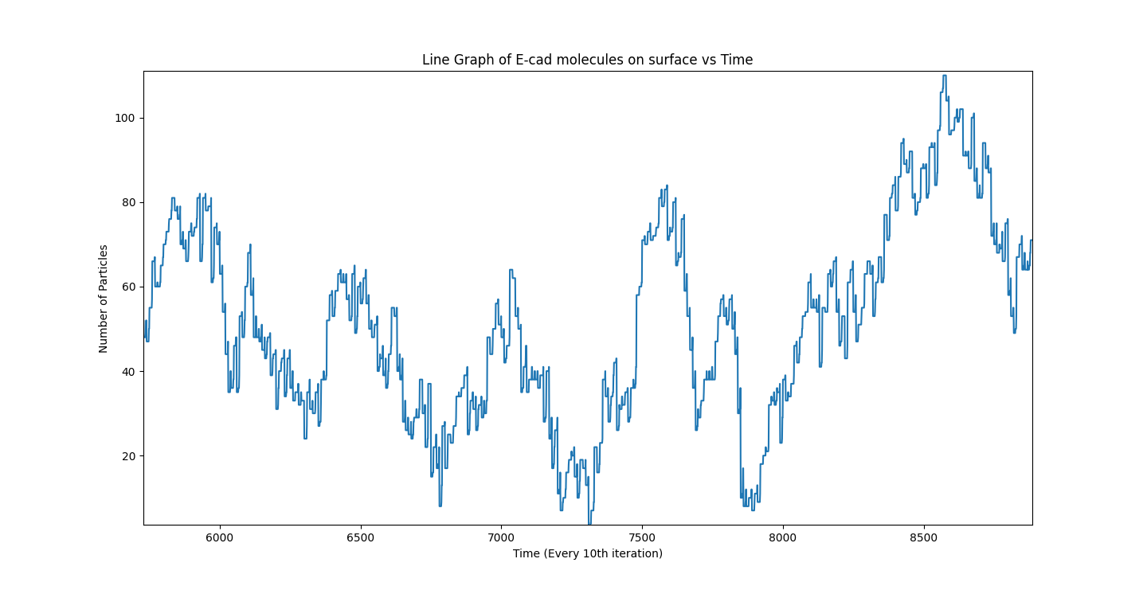

**Fig 5.2** Depicting E cad molecules on cell surface of Mutant RabX1

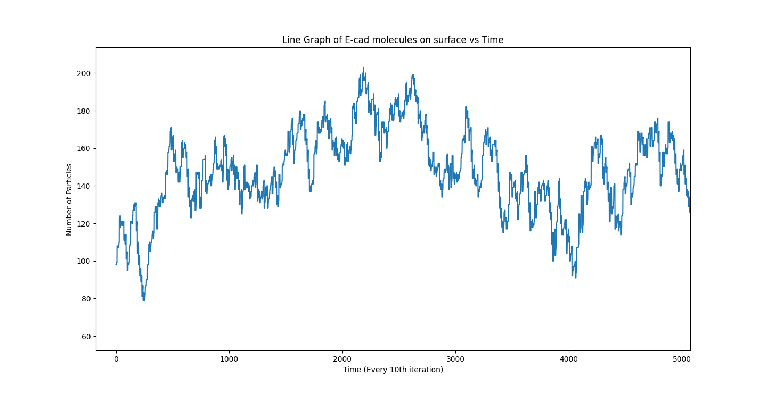

**Fig 5.3:** Depicting E cad molecules on cell surface of Wild type

**Fig5.4** : Depicting the Rab4 efficiency comparisons between all three cell types. Grey line being the Wild type, Blue line being the RabX 1 and green being the Rab11

As evident from the preceding illustrations, it becomes apparent that our results align with our initial hypothesis to a certain extent; however, they also indicate a deviation from complete conformity. Notably, an observable reduction in the abundance of molecules on the cell surface of the RabX1 mutant over time has emerged. This observation introduces a nuanced perspective on our hypothesis, suggesting that it may not entirely encapsulate the intricacies of efficiency reduction within the Rab4 system, particularly when characterized as a Hill function. One plausible avenue for further investigation could involve considering the modulation of the exponent (n_part) in the Hill function as a variable contingent upon the efficiency of the Rab11 protein system.[7]

We also see that the efficiency of the Rab4 protein changes differently for the three mechanisms based on our hypothesis and in Fig 4.2giving more accuracy to our hypothesis, we also look at the mean number of E-cad molecules present on the cell surface for all these cell types and can make an acute observation in line with research that the highest number of molecules present on cell surface are for the wild type and least for RabX1 while total molecules for Rab11 stay in between them.

**Chapter 6**

**SUMMARY AND CONCLUSIONS**

The study focuses on advancing the understanding of E-cadherin (E-cad) recycling mechanisms in cells, particularly examining the differences in these processes among wild type, RabX1 mutant, and Rab11 mutant cells. Initially, a Black-Box method was used for modeling E-cad recycling, which did not differentiate the origins of recycled particles. The new approach involves developing a computational model that incorporates all three distinct recycling mechanisms observed in these cell types.

Key findings include the identification of rapid E-cad molecule reinstatement by the Rab4 protein following endocytosis, contrasted with the more gradual reintroduction by Rab11 and RabX1 through Apicolateral and Lateral Exocytosis. This led to a hypothesis regarding temporal disparities in molecule reintegration. The model revealed that while the wild type utilizes all three pathways, Mutant RabX1 shows reduced efficiency in Apicolateral and Lateral Exocytosis, and Mutant Rab11 entirely inhibits Apicolateral Exocytosis.

The efficiency of the Rab4 protein was found to be dependent on the quantity of E-cad molecules present on the cell surface, described by a Hill function, suggesting an inverse relationship between Rab4 efficiency and the abundance of surface E-cad molecules. To reflect these dynamics, the computational model includes specific variables and functions for each mutant type and recycling process, aiming to create a more responsive and integrated model.

The study's simulations partially align with the initial hypotheses but also show deviations, particularly in the RabX1 mutant. This discrepancy suggests a more complex relationship between Rab4 efficiency and E-cad molecule abundance than initially thought. Furthermore, there is room for improvement in the model, particularly in making Rab4's efficiency variable based on the efficiency of Rab11. This adjustment could provide a more accurate representation of the biological processes and address the observed deviations.

In summary, the research provides a detailed analysis of E-cad recycling mechanisms in different cellular contexts. By integrating computational modeling with empirical observations, it enhances the understanding of protein recycling in cells and highlights the need for further exploration into these complex biological processes.

**REFERENCES**

1) Binh-An Truong Quang, Madhav Mani, Olga Markova,Thomas Lecuit, and Pierre-Francois Lenne – “Principles of E-Cadherin Supramolecular Organization In Vivo”, Current Biology 23, pg. 2197-2207, November 18, 2013

2) Danfeng Cai, Shann-Ching Chen, Mohit Prasad, Li He, Xiaobo Wang, Valerie Choesmel- Cadamuro, Jessica K. Sawyer, Gaudenz Danuser, “Mechanical Feedback through E-Cadherin Promotes Direction Sensing during Collective Cell Migration”, Cell, Volume 157, issue 5, May 2014, pg.1146-1159

3) Chiara Malinverno. et.al, “Endocytic reawakening of motility in jammed epithelia”, Nature materials 16, 587, January 2017

4) Robert J. Tetley and Yanlan Mao, “The same but different: cell intercalation as a driver of tissue deformation and fluidity”, Philosophical transactions of the royal society, Biological Sciences 373, September 2018

5) Veena Padmanaban, Ilona Krol, Yasir Suhail, Barbara M. Szczerba, Nicola Aceto, Joel S. Bader & Andrew J. Ewald, “E-cadherin is required for metastasis in multiple models of breast cancer”, Nature 573, pages: 439–444 , September 2019

6) Diego A. Vargas, Hans Van Oosterwyck, “Cell Adhesion: Basic Principles and Computational Modeling”, Encyclopedia of biomedical engineering, pg: 45-58, 2019

7) Yang Chen,Julia Brasch,Oliver J. Harrison and Tamara C. Bidone, “Computational model of E- cadherin clustering under force”, Biophysical Journal 120, pg: 4944–4954, November 2021

8) Understnading molecular simulations --- from algorithms to applications, by Daan Frenkel and Berend Smit.

9) Timothy E Vanderleest, Celia M Smits, Yi Xie, Cayla E Jewett, J Todd Blankenship , Dinah Loerke , University of Denver, US, “Vertex sliding drives intercalation by radial coupling of adhesion and actomyosin networks during Drosophila germband extension”, Computational and systems biology, developmental biology, July 2018

10) Guillaume Charras, Alpha S Yap, “Tensile Forces and Mechano-transduction at Cell-Cell Junctions”, Current Biology, 28(8):R445-R457, April 2018

11) Amit Das, Abrar Bhat, Rastko Sknepnek, Darius Köster, Satyajit Mayor, Madan Rao, “Stratification relieves constraints from steric hindrance in the generation of compact actomyosin asters at the membrane cortex”, Science Advances. 6, eaay6093 (2020).

12) Collins C, Denisin AK, Pruitt BL, Nelson WJ. Changes in E-cadherin rigidity sensing regulate cell adhesion. Proceedings of the National Academy of Sciences. 2017 Jul 18;114(29):E5835- 44.

13) Woichansky I, Beretta CA, Berns N, Riechmann V. Three mechanisms control E-cadherin localization to the zonula adherens. Nat Commun. 2016 Mar 10;7:10834. doi: 10.1038/ncomms10834. PMID: 26960923; PMCID: PMC4792928.

14) Radhikha Bagmare Endterm Report for BBD451, Batch of 2019 Biotechnology and Biochemical Engineering <https://drive.google.com/file/d/1e7-eAMUzLDibqPVemeewOvpuhIl3IuFm/view?usp=sharing>

15) B. Ladoux & R.-M. Mège. *Nat. Rev. Mol. Cell Biol.* **18**, 743 (2017).

16) A. I. Bachir, A. R. Horwitz, W. J. Nelson & J. M. Bianchini. *Cold Spring Harb. Perspect. Biol.* **9**, a023234 (2017).

17) N. C. Heer & A. C. Martin. *Development* **144**, 4249 (2017).

**APPENDICES**

1. **Python Program**

Below is the python program for E-cadherin endocytosis and Recycling mechanism:

import numpy as np

import random

import matplotlib.pyplot as plt

import cv2

from datetime import datetime

def Rab4Recycle(removed_particles_entering_rab4, rab4_efficiency):

return int(np.round(removed_particles_entering_rab4*rab4_efficiency))

def TubularRecycle(removed_particles_entering_tubular, tubular_efficiency):

return int(np.round(removed_particles_entering_tubular*tubular_efficiency))

def Rab4Efficiency(n_part):

if n_part < 40:

return 0.5

elif n_part > 100:

return 0.2

else:

return -0.005 * n_part + 0.7

def wildType(n_iter, mechanism_type):

currentDate = datetime.now().date()

currentTime = datetime.now().time()

currentTime = str(currentTime)[:8]

part_arr = []

numbers = []

L=20.0

v = 1.0

k = 1.0

arr = []

n_part = 100

vecx = [[] for i in range(n_part)]

vecy = [[] for i in range(n_part)]

for i in range(n_part):

x = random.random()*L

y = random.random()*L

vecx[i].append(x)

vecy[i].append(y)

arr.append((x,y))

endo_rate = 10

exo_rate = 10

sigma_rate = 5

freq = 100

rab4_efficiency = 0.2

lamRecycleFreqRab4 = 20

lamRecycleFreqTubular = 40

recycleFreqTubular = 40

recycleFreqRab4 = 20

tubular_efficiency = 0.4

img_names = []

for t in range(n_iter):

if t%freq==0:

fig, ax = plt.subplots()

to_printx =[]

to_printy =[]

for i in range(n_part):

to_printx.append(vecx[i][-1])

to_printy.append(vecy[i][-1])

ax.plot(to_printx, to_printy,'o')

fig.savefig(f"images_my/{mechanism_type}/graph_{t}.png")

plt.close(fig)

img_names.append(f"images_my/{mechanism_type}/graph_{t}.png")

nd = int(np.round(random.gauss(endo_rate,sigma_rate)))

while(nd>=n_part):

nd = int(np.round(random.gauss(endo_rate,sigma_rate)))

recycleFreqTubular = np.random.poisson(lam=lamRecycleFreqTubular)

recycleFreqRab4 = np.random.poisson(lam=lamRecycleFreqRab4)

recycled_particles_rab4 = Rab4Recycle(removed_particles_entering_rab4= nd*0.5, rab4_efficiency=Rab4Efficiency(n_part))

recycled_particles_tubular = TubularRecycle(removed_particles_entering_tubular=nd*0.5, tubular_efficiency=tubular_efficiency)

removed_ind = set()

while(len(removed_ind)<nd):

x = random.randint(0, n_part-1)

removed_ind.add(x)

new_indices = []

for i in range(n_part):

if i not in removed_ind:

new_indices.append(i)

tvecx=[]

tvecy = []

tarr=[]

for ind in new_indices:

tvecx.append(vecx[ind])

tvecy.append(vecy[ind])

tarr.append(arr[ind])

vecx = tvecx

vecy = tvecy

arr=tarr

na = int(np.round(random.gauss(exo_rate,sigma_rate))) - (recycled_particles_rab4 + recycled_particles_tubular)

for i in range(na):

x = random.random()*L

y = random.random()*L

vecx.append([x])

vecy.append([y])

arr.append((x,y))

n_part = len(vecx)

part_arr.append(n_part)

elif (t+recycleFreqRab4)%freq==0:

for i in range(recycled_particles_rab4):

x = random.random()*L

y = random.random()*L

vecx.append([x])

vecy.append([y])

arr.append((x,y))

n_part = len(vecx)

elif (t+recycleFreqTubular)%freq==0:

for i in range(recycled_particles_tubular):

x = random.random()*L

y = random.random()*L

vecx.append([x])

vecy.append([y])

arr.append((x,y))

n_part = len(vecx)

if t%10 == 0:

numbers.append(n_part)

total_sum = 0

for part in range(0, len(part_arr)):

total_sum += part_arr[part]

print(total_sum/len(part_arr))

plt.figure(figsize=(10,10))

plt.plot(numbers)

plt.ylim(bottom=0)

plt.title('Line Graph of E-cad molecules on surface vs Time')

plt.xlabel('Time (Every 10th iteration)')

plt.ylabel('Number of Particles')

plt.savefig(f"graphs/{mechanism_type}/graph_{currentDate} {currentTime}.png")

return img_names

def Rab11(n_iter, mechanism_type):

currentDate = datetime.now().date()

currentTime = datetime.now().time()

currentTime = str(currentTime)[:8]

part_arr = []

numbers = []

L=20.0

arr = []

n_part = 100

vecx = [[] for i in range(n_part)]

vecy = [[] for i in range(n_part)]

for i in range(n_part):

x = random.random()*L

y = random.random()*L

vecx[i].append(x)

vecy[i].append(y)

arr.append((x,y))

endo_rate = 10

exo_rate = 10

sigma_rate = 5

freq = 100

recycleFreq = 30

lamRecycleFreqRab4 = 20

lamRecycleFreqTubular = 40

recycleFreqTubular = 40

recycleFreqRab4 = 20

rab4_efficiency = 0.2

tubular_efficiency = 0.4

img_names = []

for t in range(n_iter):

if t%freq==0:

fig, ax = plt.subplots()

to_printx =[]

to_printy =[]

for i in range(n_part):

to_printx.append(vecx[i][-1])

to_printy.append(vecy[i][-1])

ax.plot(to_printx, to_printy,'o')

fig.savefig(f"images_my/{mechanism_type}/graph_{t}.png")

plt.close(fig)

img_names.append(f"images_my/{mechanism_type}/graph_{t}.png")

nd = int(np.round(random.gauss(endo_rate,sigma_rate)))

while(nd>=n_part):

nd = int(np.round(random.gauss(endo_rate,sigma_rate)))

recycleFreqTubular = np.random.poisson(lam=lamRecycleFreqTubular)

recycleFreqRab4 = np.random.poisson(lam=lamRecycleFreqRab4)

recycled_particles_rab4 = Rab4Recycle(removed_particles_entering_rab4= nd*0.5, rab4_efficiency=Rab4Efficiency(n_part))

recycled_particles_rab4_supposed = Rab4Recycle(removed_particles_entering_rab4= nd*0.5, rab4_efficiency=0.2)

recycled_particles_tubular = TubularRecycle(removed_particles_entering_tubular=nd*0.5, tubular_efficiency=tubular_efficiency)

recycled_particles_tubular_supposed = TubularRecycle(removed_particles_entering_tubular=nd*0.5, tubular_efficiency=0.4)

removed_ind = set()

while(len(removed_ind)<nd):

x = random.randint(0, n_part-1)

removed_ind.add(x)

new_indices = []

for i in range(n_part):

if i not in removed_ind:

new_indices.append(i)

tvecx=[]

tvecy = []

tarr=[]

if len(new_indices) <= 50:

rab4_efficiency = 0.3

elif len(new_indices) >= 75:

rab4_efficiency = 0.1

for ind in new_indices:

tvecx.append(vecx[ind])

tvecy.append(vecy[ind])

tarr.append(arr[ind])

vecx = tvecx

vecy = tvecy

arr=tarr

na = int(np.round(random.gauss(exo_rate,sigma_rate))) - (recycled_particles_rab4_supposed + recycled_particles_tubular_supposed)

for i in range(na):

x = random.random()*L

y = random.random()*L

vecx.append([x])

vecy.append([y])

arr.append((x,y))

n_part = len(vecx)

part_arr.append(n_part)

elif (t+recycleFreqRab4)%freq==0:

for i in range(recycled_particles_rab4):

x = random.random()*L

y = random.random()*L

vecx.append([x])

vecy.append([y])

arr.append((x,y))

n_part = len(vecx)

if t%100 == 0:

numbers.append(n_part)

total_sum = 0

for part in range(0, len(part_arr)):

total_sum += part_arr[part]

print(total_sum/len(part_arr))

plt.figure(figsize=(10,10))

plt.plot(numbers)

plt.ylim(bottom=0)

plt.title('Line Graph of E-cad molecules on surface vs Time')

plt.xlabel('Time (Every 10th iteration)')

plt.ylabel('Number of Particles')

plt.savefig(f"graphs/{mechanism_type}/graph_{currentDate} {currentTime}.png")

return img_names

def RabX1(n_iter, mechanism_type):

currentDate = datetime.now().date()

currentTime = datetime.now().time()

currentTime = str(currentTime)[:8]

part_arr = []

numbers = []

L=20.0

arr = []

n_part = 100

vecx = [[] for i in range(n_part)]

vecy = [[] for i in range(n_part)]

for i in range(n_part):

x = random.random()*L

y = random.random()*L

vecx[i].append(x)

vecy[i].append(y)

arr.append((x,y))

endo_rate = 10

exo_rate = 10

sigma_rate = 5

freq = 100

lamRecycleFreqRab4 = 20

lamRecycleFreqTubular = 40

recycleFreqTubular = 40

recycleFreqRab4 = 20

rab4_efficiency = 0.4

tubular_efficiency = 0.08

img_names = []

for t in range(n_iter):

if t%freq==0:

fig, ax = plt.subplots()

to_printx =[]

to_printy =[]

for i in range(n_part):

to_printx.append(vecx[i][-1])

to_printy.append(vecy[i][-1])

ax.plot(to_printx, to_printy,'o')

fig.savefig(f"images_my/{mechanism_type}/graph_{t}.png")

plt.close(fig)

img_names.append(f"images_my/{mechanism_type}/graph_{t}.png")

nd = int(np.round(random.gauss(endo_rate,sigma_rate)))

while(nd>=n_part):

nd = int(np.round(random.gauss(endo_rate,sigma_rate)))

recycleFreqTubular = np.random.poisson(lam=lamRecycleFreqTubular)

recycleFreqRab4 = np.random.poisson(lam=lamRecycleFreqRab4)

recycled_particles_rab4 = Rab4Recycle(removed_particles_entering_rab4= nd*0.5, rab4_efficiency=Rab4Efficiency(n_part))

recycled_particles_rab4_supposed = Rab4Recycle(removed_particles_entering_rab4= nd*0.5, rab4_efficiency=0.2)

recycled_particles_tubular = TubularRecycle(removed_particles_entering_tubular=nd*0.5, tubular_efficiency=tubular_efficiency)

recycled_particles_tubular_supposed = TubularRecycle(removed_particles_entering_tubular=nd*0.5, tubular_efficiency=0.4)

removed_ind = set()

while(len(removed_ind)<nd):

x = random.randint(0, n_part-1)

removed_ind.add(x)

new_indices = []

for i in range(n_part):

if i not in removed_ind:

new_indices.append(i)

tvecx=[]

tvecy = []

tarr=[]

if len(new_indices) <= 50:

rab4_efficiency = 0.5

elif len(new_indices) >= 75:

rab4_efficiency = 0.3

for ind in new_indices:

tvecx.append(vecx[ind])

tvecy.append(vecy[ind])

tarr.append(arr[ind])

vecx = tvecx

vecy = tvecy

arr=tarr

na = int(np.round(random.gauss(exo_rate,sigma_rate))) - (recycled_particles_rab4_supposed + recycled_particles_tubular_supposed)

for i in range(na):

x = random.random()*L

y = random.random()*L

vecx.append([x])

vecy.append([y])

arr.append((x,y))

n_part = len(vecx)

part_arr.append(n_part)

elif (t+recycleFreqRab4)%freq==0:

for i in range(recycled_particles_rab4):

x = random.random()*L

y = random.random()*L

vecx.append([x])

vecy.append([y])

arr.append((x,y))

n_part = len(vecx)

elif (t+recycleFreqTubular)%freq==0:

for i in range(recycled_particles_tubular):

x = random.random()*L

y = random.random()*L

vecx.append([x])

vecy.append([y])

arr.append((x,y))

n_part = len(vecx)

if t%10 == 0:

numbers.append(n_part)

total_sum = 0

for part in range(0, len(part_arr)):

total_sum += part_arr[part]

print(total_sum/len(part_arr))

plt.figure(figsize=(10,10))

plt.plot(numbers)

plt.ylim(bottom=0)

plt.title('Line Graph of E-cad molecules on surface vs Time')

plt.xlabel('Time (Every 10th iteration)')

plt.ylabel('Number of Particles')

plt.savefig(f"graphs/{mechanism_type}/graph_{currentDate} {currentTime}.png")

return img_names

def modelECAD():

currentDate = datetime.now().date()

currentTime = datetime.now().time()

print("Generating random value for V between 0 and 1 ")

n_iter = int(input("Enter the number of iterations :"))

mechanism_type = str(input("Which Type of Mechanism do you want to run? A. Wild Type B. Rab11 C. RabX1 "))

img_names = []

if mechanism_type == "A" or mechanism_type == "a":

mechanism_type = "wild_type"

img_names = wildType(n_iter, mechanism_type)

elif mechanism_type == "B" or mechanism_type == "b":

mechanism_type = "rab11"

img_names = Rab11(n_iter, mechanism_type)

elif mechanism_type == "C" or mechanism_type == "c":

mechanism_type = "rabx1"

img_names = RabX1(n_iter, mechanism_type)

print("pre-processing done!")

codec = cv2.VideoWriter_fourcc(*"mp4v")

out = cv2.VideoWriter(f"videos_my/{mechanism_type}/output {currentDate} {currentTime}.mp4", codec, 18, (640, 480))

for i in range(len(img_names)):

img = cv2.imread(img_names[i])

out.write(img)

plt.show()

out.release()

cv2.destroyAllWindows()

print("done!")

modelECAD()